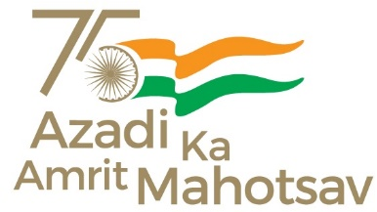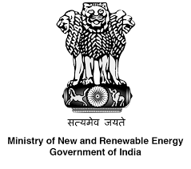

“NEW FRONTIERS: A Programme on Renewable Energy”
16-18 February 2022
The Government of India launched the “Azadi ka Amrit Mahotsav (AKAM)” on 12th March 2021 to celebrate and commemorate 75 years of progressive India and the glorious history of its people, culture and achievements. The Mahotsav is a 75 week long programme which will run through till 15th August 2023. During the Mahotsav, all Departments and Ministries would be hosting a set of activities celebrating a resurgent, Aatmanirbhar Bharat. Ministry of Culture is the nodal Ministry for the Mahotsav.
The National Implementation Committee (NIC), chaired by Hon'ble Home Minister, approved the events to be conducted for the celebration of the Mahotsav on 9th December 2021. The Ministry of New and Renewable Energy was mandated to organize a special programme on renewable energy in February 2022. Accordingly, the Ministry is organizing the “New Frontiers: A programme on Renewable Energy” on 16-18 February 2022.
The event will celebrate India’s remarkable journey in the field of new and renewable energy and also deliberate upon possible plans for achieving 500 GW of installed power capacity from non-fossil fuels based sources by 2030.
The special features of MNRE’s AKAM celebrations include:
- A special event- In conversation with Hon’ble Minister, Power and NRE
- Special addresses by Secretary, MNRE and Secretary, MoEFCC
- Snapshot of Indian Energy Compacts submitted to the UN and launch of a compilation of these compacts- Felicitation of compacts
- Webinar on “Women in RE- Call for Action”
- Webinar on “Role of ISA in Energy Transition”
- Webinar on “Role of clean-tech start-ups/climate entrepreneur in providing clean and affordable energy”
- Multi stakeholders’ Chintan Baithak on “Roadmap to Net Zero by 2070”

